Nonstop RPM

Real-time
Process
Monitor

External Specification

February 7, 2008

Version 0.20

Real-time Process Monitor (RPM)

Contents

1 Overview 3
1.1 Background 3
1.2 Rationale 3
1.3 Real-time Process Monitor (RPM) 3
1.4 Feature Summary 4
2 Interfaces 4
2.1 TTY Interface 5
2.1.1 TTY Interface Example 5
2.2 T6530 Interfaces 6
2.2.1 T6530 Conversational Interface Example 6
2.2.2 T6530 Block-Mode Interface Example 7
2.3 VT100 Interface 8
2.3.1 VT100 Interface Example #1 8
2.3.2 TTY Interface Example #2 9
2.4 Fat Client Interface 10
2.4.1 Fat Client - Example #1 - Overview 10
2.4.2 Fat Client - Example #2 - Fast Historical stats 11
2.4.3 Fat Client - Example #3 - State Filtering 12
2.4.4 Fat Client - Example #4 - Super-cluster SORTs 13
2.5 Thin Client Interface 14
2.5.1 Thin Client - Example - Integrated filtered multi-report display 14
3 Installation 15
3.1 Install Details 15
3.2 RpmCNF file 15
4 Commands 16
4.1 Overview 16
4.2 ADD command 17
4.3 CPU command 18
4.4 PB command 19
4.5 NODES command 21
4.6 SET command 22
4.7 STATUS command 23
4.8 T6530 command 23
4.9 VT100 command 24
4.10 ZOOM command 25

Overview
This paper describes a new HP NonStop Enterprise Division product utility that provides low-cost Cpu and Process monitoring. The core requirements and design are based on years of customer feedback, as well as long term experience monitoring NonStop server performance.

Background
HP development has been repeatedly approached by customers over the years asking whether HP would formalize an official low-cost HP product that provided fast Cpu and Process monitoring by Cpu, by node, or expand super-cluster. Key requirements were that the utility must be low-cost, that it must support standard T6530 / VT100 devices, must monitor both OSS and NSK processes, and only optionally via fat and thin clients. In particular customers are looking for a low-cost command line utility; that instantaneously and repeatedly displays real-time Cpu and Process activity; and that informs customers which processors and processes use the most Cpu; and that quickly reports stats by Cpus, nodes, or a whole expand-super-cluster.

While there are products that occupy limited portions of this space, none fit the requirements above. For example, ViewSys does the Cpu piece of this, has nice graphics, but for 1 node, and for T6530, and does not provide busiest process info. Further other products do not support clusters, nor support VT100, nor support OSS and NSK. There are very much more expensive products that do limited forms of this on NonStop. But they do not provide fast interactive access with color encoding on T6530 or VT100 devices with support for OSS and NSK object names (nor are they accessible from TACL and an OSH prompt). Other key differentiators are that other products are very much more expensive, and still don’t provide ultra-fast, ultra-light, real-time process busy stats on Cpus, nodes, and expand super-clusters with updates every few seconds.

There have been some unofficial "utilities" over the years that have attempted to address this space; Offender was a buggy "skunk-works" tool that occasionally was “shared” with NonStop customers over the years, but it has no official support and is 6530 only, it also doesn’t support clusters, OSS names, and doesn’t color encode info. Offender also has a number of problems, including “buggy”, high-risk, non-QA code on customer systems, with no T-num, no GCSC support, no documentation, no development support, and known customer support issues.

Rationale
Given the situation described above, and existing tools within HP development there is valid justification for the release of a product that provides low-cost, Cpu/Process busy monitoring on NonStop and/or Neoview servers. As a result of on-going customer requests for such a utility and due to development’s need to better understand short-term timing dynamics of products such as TimeSync, ViewSys, and ASAP in NonStop and NeoView clusters, development has created a high quality product (called RPM for Real-time Process Monitor). This code has evolved over the past 3 years to address a wide range of testing and analysis scenarios (including viewing inter-node Time-sync). Since customers also benefit from such a utility, thus this product release.

Real-time Process Monitor (RPM)
Real-time Process Monitor (RPM) is a monitoring utility. It is of product-level quality construction and reliability, and is now available to HP customers. RPM provides real-time monitoring of processors, processes, and clusters with an “old-school” utilitarian twist providing a wide-range of user interfaces including: TTY, T6530, VT100, Fat, and Thin clients. Customers require an officially supported product that addresses needs in this area. An in-expensive Cpu/Process monitoring utility that satisfies the requirements above is welcome by many; RPM addresses long-term issues with skunk works "products" such as Offender; addresses node-clusters, and is applicable to ad hoc monitoring of NonStop/Neoview Cpus, nodes, and clusters.

Feature Summary

The following summarizes basic features of the RPM utility. The product name is Real-time Process Monitor (RPM). It is important to understand that RPM is a utility; it is not some new be-all and end-all OM architecture. Nor is it meant to be the foundation for some future architecture, it is simply a utility that addresses an important point-product problem space unique to NonStop and Neoview servers, e.g. analyze busy OSS/NSK processes in Cpus, nodes, and clusters.

Benefits

- Allows customers/analysts to see activity by Cpu, Node, or Cluster.

- Finds busy processes in a Cpu, Node, or Cluster every few seconds.

- Run line configurable; addresses wide variety of interfaces and configurations.

- Provides Cpu/Process monitoring of Cpus, Nodes, and Cluster configurations.

- Instantaneous startup displays, fast sample times, low-overhead, even if started cold.
- By Cpu displays busiest processes in a particular Cpu

- By Node displays busiest processes in a particular Node

- By Cluster displays busiest processes across Super-cluster

- Results can be sorted, filtered, color-encoded in real-time by Cpu, Node, or Cluster.

- Supports following interfaces - TTY, T6530, VT100, Fat*, Thin clients*

Interfaces

RPM provides the following interfaces:

- TTY Plain text terminal support

- T6530 T6530 conversational video encoding

- T6530 T6530 block-mode with independent scrolling

- VT100 VT100 color-encoding and super-sized support

- Fat Client Graphs, grids, state icons, tree views

- Thin Client Integrated single page website that updates every few seconds.

All examples on the following pages represent real working code. The screen shots are not mock-ups, but are working displays. Virtual Classroom can be provided if anyone who would like to see it in operation, or you can obtain it by emailing - support@NonstopRPM.com.

TTY Interface
The TTY interface addresses two requirements:
1) Dumb terminal device support allows RPM monitoring from virtually any workstation.
2) Conformance to the "command language standard" provides structured table output for use with add-on products such as ASAP, Dashboard, etc. Thus RPM can be used to stream statistics to files or processes using standard raw-table technology.

TTY Interface Example
Example output below is the result of a PB \*, TTY, ByNode, RATE 10, ENTRIES 15 command. This command causes RPM to display the 15 busiest processes in each node of a super-cluster and to repeat every 10 seconds (note - the notion of a cluster can be user defined).
Displays can also provide other detailed information, such as the time-of-day on each of the nodes in the cluster. For example, note that nodes below are NOT in sync. Our development team uses this utility to grossly monitor time of day and to track TimeSync status on nodes in a super-cluster (note how time-of-day on the first node \Centdiv can be displayed in microseconds).

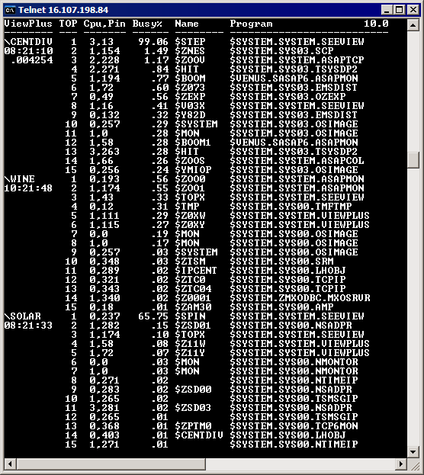

T6530 Interfaces

There are two T6530 interfaces:

- Conversation color encoded interface

- Block-mode independently scrollable interface

T6530 Conversational Interface Example
The example below is result of a P\* T6530, ByNode, Rate 6, Entries 7 command. This displays the 7 busiest processes in each node of a super-cluster and updates every 6 seconds (the notion of a cluster is user defined). Displays also provide more detailed information, such as the time-of-day on each of the nodes in the cluster. Note it shows us that the nodes are NOT in sync.

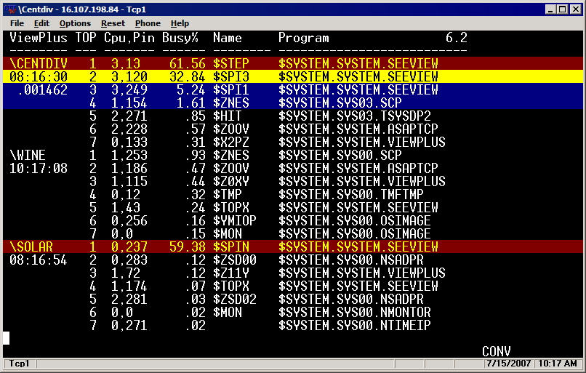
Features

- Virtually all T6530 emulators support CONVersational video.

- Provides instant display of the busiest processes in a Cluster while remaining in T6530 conversational mode. Use of video attributes and the SET ALERTS option such as:
SET CRIT 50 , WARN 10 , INFO 1

- Thresholds provide a trivial easy-to-understand scheme.

T6530 Block-Mode Interface Example

The example below is the result of two commands:
CPU * RATE 10, DETAIL; and
PB * RATE 10, ENTRIES 12

These commands display both the Cpus in a node and 12 busiest processes in the node (note that RPM can operate at the Cpu level, the single Node level, or across an entire Cluster). To be sure, users don't need an Expand network or a cluster to use RPM.

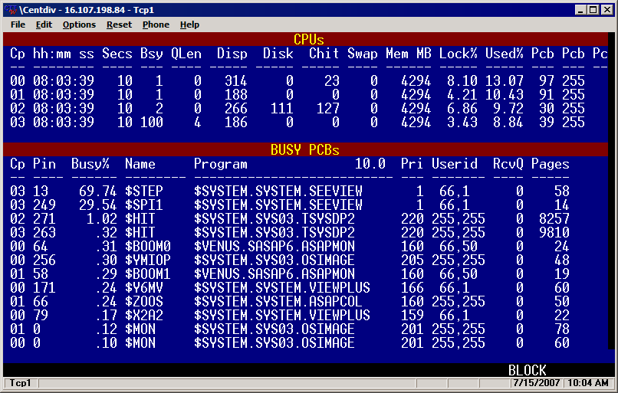

Features

- Cpu statistics in top frame.

- Process Stats in lower frame

- Block mode interface provides concurrent display of disjoint Cpu/PB statistics.
For example, top and bottom sections of display independently page and scroll.

- Information provided includes the following: (there are options for other detail)
Cpu - Busy, Q-length, Dispatches, Disk I/O, Cache Hits, Swaps, Memory MB, Memory Locked%, Used%, Pcb, PcbX use and configured.
Processes - Busiest Cpu, Pin, Busy, Name, Program, Priority, Userid, RecvQ, Memory Pages (much more detail is possible).

VT100 Interface
The VT100 interface is ubiquitous on all Windows/Unix/Linux devices. RPM supports VT100 and ANSI devices. Thus it can run on these without the need for special emulator software.

VT100 Interface Example #1
The example below is the result of a P \* VT100, ByNode, RATE 10, ENTRIES 15 command. This displays the 15 busiest processes in each node of a super-cluster (the notion of a cluster is user defined, see ADD command below). Displays can also provide more detailed information, such as userid, priority, memory use, etc.

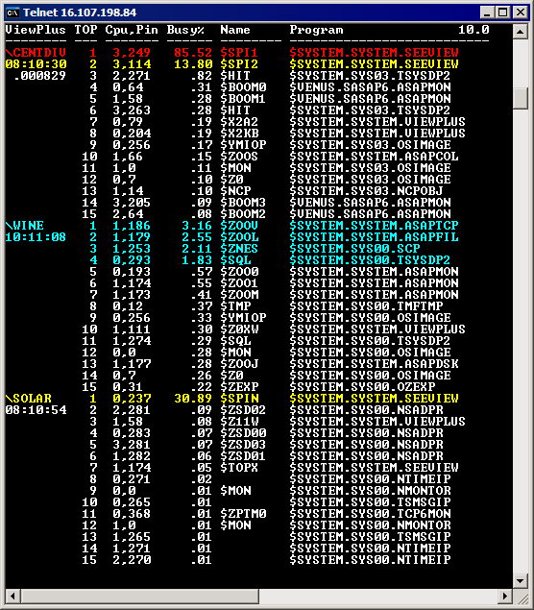
Aside from ubiquitous access from Windows, Linux, and Unix devices; other major VT100 benefits include the fact that VT100 screen sizes are variable. VT100 device Width x Height can in fact be "super-sized" so very large clusters can be monitored out-of-the-box. For example, you can super-size the VT100 built into TELNET on Windows/XP. The Windows Version of Telnet supports 1000s of lines and hundreds of columns. Thus, users can store hours of fast short term history in the terminal device, and quickly peruse backward thru the display. You can also display additional detail by using super-wide stats displays as shown below...

TTY Interface Example #2
The example below is the result of a P\*VT100, ByNode, R10, E15, DETAIL command. This displays the 15 busiest processes in each node of a super-cluster and updates every 10 seconds (the notion of a cluster is user defined with the ADD command, see below).

Displays also provide more detailed information, such as userid, priority, RecQ, Pages. Because VT100 device Width x Height can be "super-sized" very large clusters can be monitored out-of-the-box, eg Windows Telnet supports ANSI/VT100, and supports 200 visual line displays. NOTE this means RPM can be used to provide extreme detailed, real-time monitoring of large 1024p/64-node super-clusters in a single display.

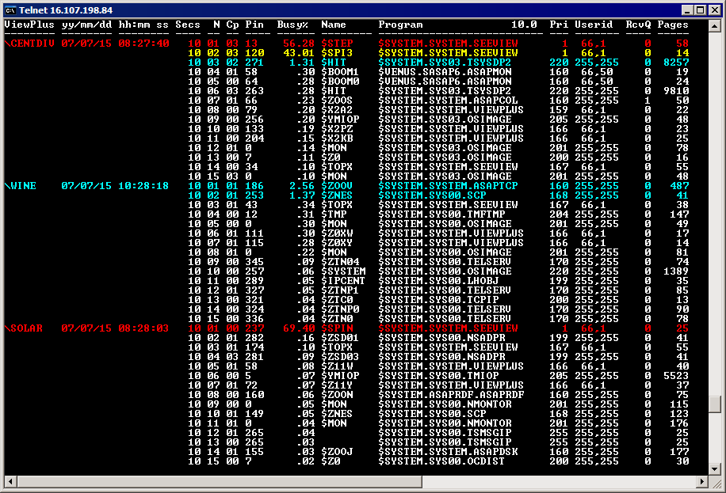

Fat Client Interface
While not required for use, there is a rich fat client interface that may eventually be released to display fast real-time RPM statistics. Features of the interface include:
- Rich Fat Client interface
- Graphs, Annotated Grids, States, Icons, Sorts, Tree views, in color-encoded interface
- Drop-downs provide switching from one node to another node, or all nodes
- Drop-downs allow selection of Top “N” busy processes.
- Options allow display of full cluster, selected nodes, or selected Cpus with wildcards.
- Users can customize views on multiple entities at the same time
- Interfaces allows creation of many windows with different views, history, filters, ..
- Displays are FAST, with real-time display updates, eg 5-10 second updates.

Fat Client - Example #1 - Overview
The example below shows busiest processes in a super-cluster. Information is presented both graphically in a graph of each busy process in the upper portion of the display, and in the lower portion an annotated grid appears of the busiest processes showing Critical, Warning, and High use alert icons. Note that objects can be sorted and/or filtered based on performance state.

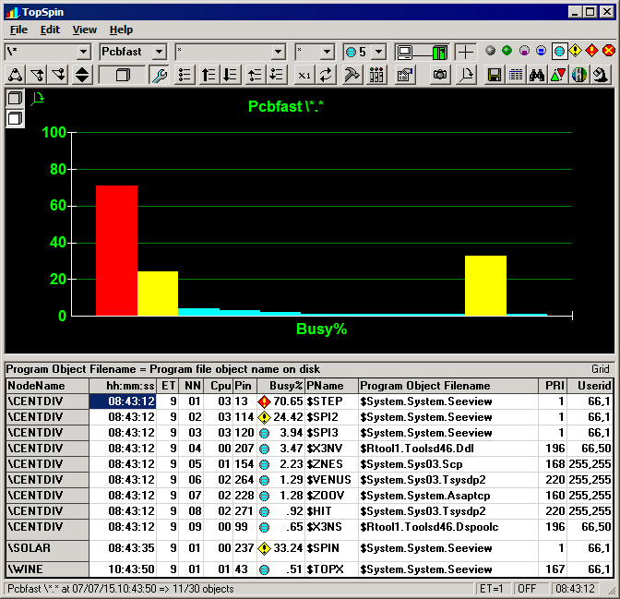

Fat Client - Example #2 - Fast Historical stats
The example below is an example of an interface that may eventually be released, it displays the busiest process in a node during the past 5 minutes (note it can also do this for all nodes).

The display rapidly updates graphs and grids for very fast, short term history displays. The display can be configured to update every few seconds, and to include a graphic display of the busiest processes during each 10 second period over the past 5 minutes.

The Samples drop-down is set to 30, meaning the display is for 30x10 = 300 seconds; or an elapsed time of 5 minutes for the overall display (note the time column, and that history can be scrolled). Columns can also be sorted.

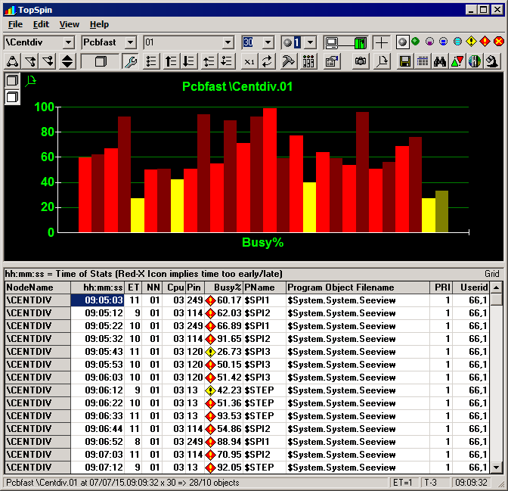

Fat Client - Example #3 - State Filtering

The example below is an example of an interface that may eventually be released, it shows how the Fat client can be used to perform State filtering on fast short term RPM statistics.

In this example, the "High Use" state filter has been selected to filter out all but the busiest "High Use" processes. Note how the High Use icon is highlighted at base of the cloud in upper right corner of the screen shot

The State Filter eliminates all but the busiest processes from the display. The result is that only the busiest of the busy processes in the Super-Cluster are displayed. Likewise other states can be used, eg Warning, Critical, or Down. In the example below only objects that have "High" use are displayed, in this case, only 11 out of 30 objects are displayed (note status bar at the bottom).

State
Filter
High Use

Fat Client - Example #4 - Super-cluster SORTs
The example below is an example of an interface that may eventually be released, it shows how you can use RPM to Sort on any attribute. RPM sorts are persistent, eg they remain in affect even after updates occur, thus they providing a continuously updating sorted display on any property. In the example below, all Busy processes in the Super-Cluster are sorted by Busy% (note incidentally they also have with state filtering turned on, so not only is the display sorted, but only shows objects with High Use states or worse are displayed). Thus only “high use” state processes are graphed and sorted in order of busiest to least busy.

Note the two busiest processes are on different nodes of the cluster.
\Centdiv - 39.16% - $SPI3
\Solar 30.41% - $SPIN
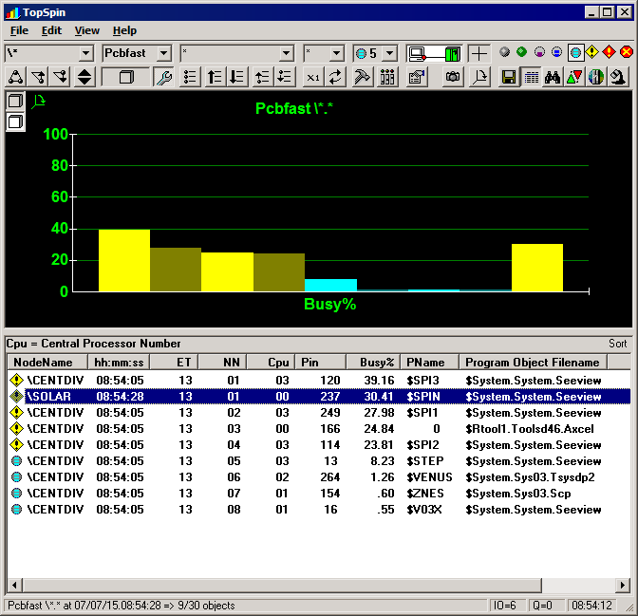
State Filter
High Use
Sort By Busy%

Thin Client Interface
The example below is an example of an interface that may eventually be released, while not required for use, there is a ubiquitous HTML 4.0 web-site interface for continuously updating display of fast real-time stats in a super-cluster. This allows fast RPM stats to be viewed from any browser.

The example below shows how the RPM thin client interface provides an integrated display of multiple report types in a single Web page. This page includes:

- Scoreboard matrix of Entity x State counts (see top of the page)
- CPU Report of the busiest Cpus in the cluster (state filtered on High Use, see middle of page)
- Busiest Process report in the cluster (state filtered on High Use, see bottom of page)
Reports are combined together into a single display that updates every few seconds.

Thin Client - Example - Integrated filtered multi-report display
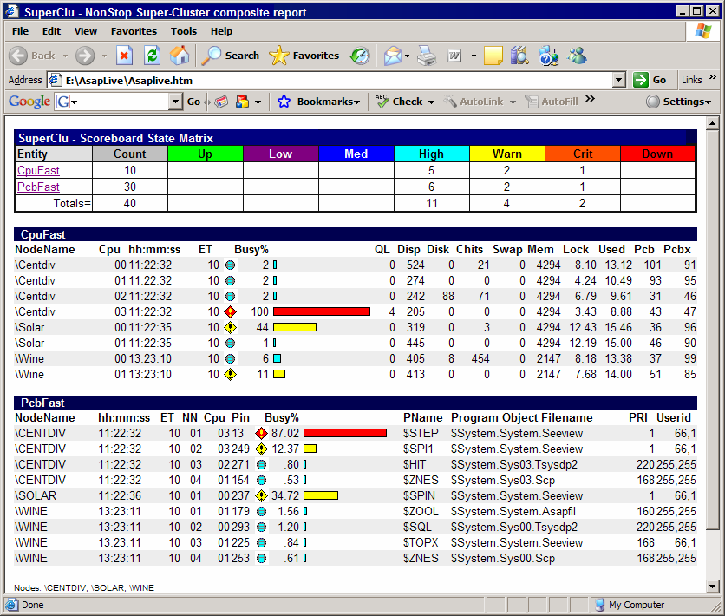

Installation

RPM installation is simple. Simply place the RPM object file in the $System.System.* subvolume on each node to be monitored. Because RPM operates in a super-cluster you need to pay attention to security issues. Make sure the object file is secured so anyone can execute it. Failure to do this will restrict who can run RPM. Remember, standard security applies, you must have remote passwords between the nodes you wish to monitor.

Install Details

To install RPM, simply do the following:

TACL 1 > FUP DUP RPM, $SYSTEM.SYSTEM.*
TACL 2 > FUP SECURE RPM, NNNN

Do this for each node or segment of a cluster you want to monitor. Be certain userids have valid remotepasswords between nodes and that the object file is secured so users can run it.

Whenever you run RPM, you can obtain install help text by entering HELP INSTALL:

TACL 1 > RPM
+ HELP INSTALL

RpmCNF file

RPM will automatically obey an edit file named <object>CNF, such as RPMCNF, if that file is present when RPM is started. You can include ADD \SYSNAME commands in the CNF file for each node that you wish to monitor. Note each user can have different CNF files since the search path for the RPMCNF file is first in the startup default volume, then $System.System.

Thus by placing a RPMCNF file on the $System.System subvol all users can share a common auto-obey file, or individual users can have their own custom obey file to define their own view.

Example - RPMCNF file

ADD \node1 ! add \node1 to list of nodes
ADD \node2 ! add \node2 to list of nodes
ADD \node3 ! add \node3 to list of nodes
SET TERM VT100 ! define default term type, VT100, T6530, TTY
SET ENTRIES 5 ! show top 5 on each cpu/node
SET SORT BYNODE ! sort across all cpus in each node
SET CRIT 50 ! set Critical alert busy threshold 50%
SET WARN 10 ! set Warning alert busy threshold 10%
SET INFO 1 ! set Info alert busy threshold 1%
SET RATE 10 ! set refresh rate in seconds
Z \* ! show Cpus and Processes in cluster every 10 sec

Commands

Overview

If you run RPM from a TACL prompt and enter HELP, the following information is displayed..

TACL 1 > RPM

+ HELP

ALL Commands. For setup/installation info enter HELP INSTALL

----- Monitoring commands -----

CPU Display realtime CPU statistics. Enter H CPU for more info
PB Display realtime ProcessBusy stats. Enter H PB for more info
SET Sets/Shows option settings. Enter H SET for more info
ZOOM Displays blended CPU and PB stats. Enter H ZOO for more info

----- Supporting commands -----

ADD Add \<node> to list of nodes for cluster analysis
EXIT causes program to terminate
FC standard tandem fix command
HELP provides description of commands
NODES Shows nodes that have been added via the ADD command
OBEY causes commands to be executed in an OBEY file
PAUSE suspend until stop/abend/brk msg
RUN runs specified program
STATUS displays status of SSG or process by $pid
SYSTEM allows setting/display of system
T6530 Sets T6530 terminal support
VOLUME allows setting/display of default volume
VT100 Sets VT100 terminal support

ADD command

ADD \<node-name>

The ADD \<node-name> command adds a node to the list of RPM nodes to be monitored.

Once nodes are added, whenever you use commands that support the \* syntax, info for the added nodes is displayed.

Commands that support the \* construct include the CPU \*, PB \*, or ZOOM \* commands.

For more information about commands that provide the \* construct, enter:

HELP CPU

HELP PB

HELP ZOOM

EXAMPLE

ADD \CHICAGO
ADD \NEWYORK
ADD \SANFRAN
ADD \DALLAS
ADD \DENVER
SET ENTRIES 3
SET RATE 6
P \*

CPU command

CPU | C [ \* | \SYSNAME ] [ BUSY | % <value> ]
[ DETAIL | NORMAL ]
[ LAST ]
[ MEMORY | MB | PCT ]
[ NOCLEAR ]
[ RATE <seconds> ]
[ TAB ]
[ VT100 | T6530 | TTY ]

The CPU or C command displays fast real-time CPU statistics displays.

BUSY | % <value> specifies the Cpu Busy threshold required for a Cpu to be displayed.
Cpus busy must be greater than or equal to the <value> specified in order to be displayed.
Cpus with a busy value less than <value> are not displayed. Default is 0, so that all Cpus are displayed by default.

DETAIL | NORMAL controls how much detail is displayed.

LAST causes stats to be displayed based on the requestors rate. The last option is an adaptive rate, if the requestor makes a request every 3 seconds, but then starts making requests every
5 seconds, the CPU command with the LAST option automatically adapts to the requestors request rate. LAST means use the stats counters from the LAST request with new stats. Display
occurs once, with calculations based on time between commands.

MEMORY shows page-size, total memory, swappable, locked, and free memory in either pages or if MB specified then in units of megabytes. If PCT is specified, then in percent total memory.

RATE <seconds> causes stats display to repeat every <seconds>. If RATE is zero, the display is updated once, with rates and busy calculations based on 1 second sample interval unless LAST is specified. Note the default value of RATE is controlled by SET RATE <seconds>.

TAB outputs "09" tab characters between output columns.

VT100 | T6530 | TTY - sets terminal type. Note the SET ALERTS ON|OFF option controls CRIT, WARN, INFO thresholds and the display of color-coded alerts. See HELP SET for more info.

EXAMPLES

CPU \* ! show all Cpus in super-cluster
C\* ! same as CPU \*
C RATE 6 ! show Cpu stats, repeat every 6 seconds
C MEM ! show Cpu Memory stats in pages
C MB ! show Cpu Memory stats in megabytes
C PCT ! show Cpu Memory stats utilization
C\* %1 ! show Cpus greater than or equal to 1% busy

PB command

PB | P [ \* | * | <cpu> ] [ BUSY | % <value> ]
[ BYCPU | BYNODE ]
[ DETAIL ]
[ ENTRIES <N> ]
[ LAST ]
[ NONULL ]
[ NORMAL ]
[ RATE <seconds> ]
[ SAME ]
[ SYNC ]
[ TAB ]
[ USECS ]
[ VT100 | T6530 | TTY ]

The PB or P command displays quick real-time process statistics. The <N> busiest processes in each Cpu, Node, or Super-cluster of nodes are displayed. Basic examples...

PB displays N busiest processes on node
P * displays N busiest processes on node (same as PB)
P <cpu> displays N busiest processes for <cpu>
P \* displays N busiest processes in \nodes (see ADD command)

PB command options include...

BUSY | % <value> specifies the Process Busy threshold required for a process to be displayed. Process busy must be greater than or equal to the <value> specified in order to be displayed.
Processes with a busy value less than <value> are not displayed. Default value is 0, so all processes up to ENTRIES <N> count are displayed.

BYCPU | BYNODE - controls display order of the top <N> busiest processes.
BYCPU displays the busiest processes in each Cpu.

BYNODE displays the busiest processes across all Cpus in each node in one list of processes sorted from busiest to least busy process. If you do not specify this option, the busiest
processes are listed ByNode, unless you specify SET SORT ByCPU.
*NOTE* users can globally set sort order by using SET SORT option.

DETAIL - displays additional stats such as node name, priority, accessorid, receive queue length, memory pages in use.

ENTRIES <N> - displays the <N> busiest processes either in all Cpus in a node, or the <N> busiest in each Cpu. Note ENTRIES can be abbreviated as E, and no space is required, thus P\*,E3,R6 is valid.

LAST - causes stats to be displayed based on the requestors rate. The last option is an adaptive rate. For example, if a requestor makes a request every 3 seconds, but then starts making requests every 5 seconds, the PB command with a LAST option automatically adapts to the requestors request rate. LAST means RPM should use the stats counters from the LAST request for the new display. Display occurs once, with calculations based on elapsed time between PB commands. See also SAME and RATE options.

NONULL - suppresses display of processes consuming less than %0.00 Cpu busy.

NORMAL - displays the default output: Time, Cpu, Pin, Busy, Name, Program. Note the DETAIL option provides additional information.

RATE <seconds> - causes stats display to repeat every <seconds>. If RATE is zero, the display is updated once, with rates and busy calculations based on 1 second sample interval, unless LAST is specified. Note the default value of RATE is controlled by the SET RATE <seconds> option. Note RATE can be abbreviated, thus P\*,R5 is allowed.

SAME - displays the same stats as the prior PB command, but for different <cpus> or with different DETAIL.
Same examples:
PB 1,LAST could be followed by
PB,SAME,ALL or by
PB 1,SAME,DETAIL to display additional info about the same set of statistics.

SYNC - synchronizes reporting to begin at modulo seconds past the minute. For example, PB RATE 6 would report at 6, 12, 18, 24, 30, 36, 42, 48, and 54 seconds past the minute (is default).

TAB - outputs '09' tab control characters between output columns.

USECS - show time of day in microseconds in the NORMAL display only.

VT100 | T6530 | TTY - sets terminal type. Note that the SET ALERTS ON|OFF option controls whether CRIT, WARN, INFO thresholds display color coded alerts. See HELP SET for more info.

EXAMPLES

PB *, ENTRIES 10, RATE 6, NONULL, DETAIL, BYCPU
P *, E10, R6, NON, DET, BYC ! save as above, but abbreviated
P BYNODE, ENTRIES 22, LAST, DETAIL, TAB, RATE 10
P T6530
P VT100
P \*, E5, BYCPU ! show 5 busiest in each Cpu in all ADD nodes
P \* %1 ! show processes greater/equal to 1 percent busy

*NOTE* There are also TTY, VT100, and T6530 commands. Enter HELP for those commands to obtain more info about support for these devices. Also note that any command can be added to a file named <object>CNF file in your default subvolume, or on $system.system.*

NODES command

NODES

NODES displays list of added nodes for real-time CPU and process statistics analysis.

EXAMPLE

NODES

SET command

SET | S [ ALERTS ON|OFF ]
[ CRIT <percent-busy> ]
[ WARN <percent-busy> ]
[ INFO <percent-busy> ]
[ BUSY | % <percent-busy> ]
[ BUSYCPU <percent-busy> ]
[ BUSYPB <percent-busy> ]
[ ENTRIES <number> ]
[ LOGGING ON|OFF ]
[ LOGFILE <filename> ]
[ OBEYESCAPE ON|OFF ]
[ SORT ByCpu | ByNode ]
[ TRACETOKEN ON|OFF ]
[ USECS ON|OFF ]
[ RATE <default-seconds> ]
[ TERM TTY | VT100 | T6530 ]

SET or S command controls properties of the run-time environment.

ALERTS ON|OFF controls when objects are color highlighted using the CRIT, WARN, INFO busy threshold options...
CRIT <percent> value of Cpu Busy threshold for Critical alerts.
WARN <percent> value of Cpu Busy threshold for Warning alerts.
INFO <percent> value of Cpu Busy threshold for Info alerts.

BUSY | % | BUSYCPU | BUSYPB <percent> indicates the default busy threshold value.
If BUSY|% <value> is specified then <percent> applies to both the CPU and PB commands. Specifying separate BUSYCPU <percent> or BUSYPB <percent> independently specifies the
BUSY value for the CPU and/or PB commands respectively.

ENTRIES <number> controls the default value of the ENTRIES option for the PB command.

OBEYESCAPE ON|OFF controls behavior of interactive commands encountered in an OBEY file. ON implies interactive commands such as CPU and PB will 'escape' from the OBEY file, eg end
the obey file and instead be executed interactively. If ON and BREAK is pressed, the program will prompt for more commands. If OFF then and BREAK is pressed, then a TACL prompt appears,
and pausing TACL will cause program to continue.

SORT ByCpu | ByNode - controls the display order of the top <N> busiest processes. 'ByCpu' displays busiest processes in each Cpu. 'ByNode' displays the busiest processes across all Cpus in each node in one list of processes sorted from busiest to least busy processes. If you do not specify this option, the busiest processes are listed ByNode. *NOTE* you can globally set this
option with the SET SORT ByCpu | ByNode option.

RATE <default-seconds> controls the default value of the RATE <seconds> option for the CPU and PB commands. Note this value can be changed without changing the default value by
specifying RATE <seconds> on the CPU or PB command.

TERM TTY | VT100 | T6530 indicates terminal type for video. TTY is text only with no video alerts/enhancement provided.

USECS - ON|OFF controls the default value of USECS in the PB command. This option shows time of day in microseconds for the NORMAL display.

EXAMPLES

SET TERM TTY ! use no video
SET TERM VT100 ! use VT100 video
SET TERM T6530 ! use T6530 video
SET ALERTS ON CRIT 50 WARN 10 INFO 1
SET %1 ! Only show Cpus/Processes greater/equal to 1% busy

STATUS command

STATUS [ SSG | [\<node>].$<PID> ]

The STATUS command displays the status of super-server-gateway (SSG) processes or a $PID.

EXAMPLES

STATUS ! show status of all SSG's
STATUS SSG ! same as STATUS
STATUS $ZSCX ! show status of pid $ZSCX

T6530 command

T6530

The T6530 command is equivalent to entering SET TERM T6530.

NOTE - you can put commands in <object>CNF file, where <object> is the name of this program.

For example if the program object file name is "RPM" then you can create a file named RPMCNF and then whenever you run RPM it will automatically obey all the commands that are contained in the file RPMCNF.

File RPMCNF:
ADD \node1
ADD \node2
ADD \node3
SET TERM T6530
SET RATE 10
SET ENTRIES 6
P \*

VT100 command

VT100

VT100 terminal support is present generically in nearly all Windows, Linux, and Unix devices.
For example on any Windows/XP device you access VT100 emulation simply by entering

C:> TELNET <ip-address>

Entering the above from a DOS or "command prompt" will connect to the specified host, and if you click on the "control box" you can SUPER-SIZE the VT100's screen Width x Height to be 1000s of lines long and hundreds of characters wide.

VT100 command is equivalent to SET TERM VT100.

You can put SET commands in a file named <object>CNF file, where <object> is the name of this program. For example if the program object file name is "RPM" and you create a file named RPMCNF, then whenever RPM runs it will automatically obey all commands in the file RPMCNF.

File RPMCNF:
ADD \node1
ADD \node2
ADD \node3
SET TERM VT100
SET INFO 1 WARN 10 CRIT 50
SET RATE 6
SET ENTRIES 15
P \*

ZOOM command
ZOOM | Z [ \* | \sysname ] [ BUSY | % | BUSYCPU | BUSYPB <percent> ]
[ DETAIL ]
[ NORMAL ]
[ ENTRIES <num> ]
[ MEM | MB | PCT ]
[ TTY|T6530|VT100 ]
[ RATE <secs> ]
[ USECS ]

The ZOOM command provides a blended display of both Cpu and Process statistics.
See CPU, PB, and SET commands for an explanation of the options above. Example: Z\*

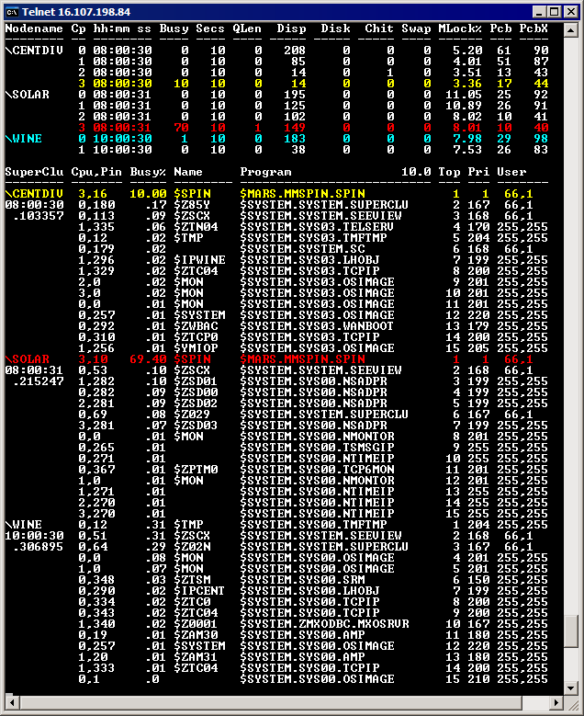

* Fat/Thin client capabilities in this ES are not part of the core product, but are envisioned as optional add-on capabilities given that the market for the core product justifies release of fat/thin interfaces.

